SOFTWARE ENGINEERING
Assignment: Wireframe



Submitted By:
Name: Umair Arshad
Reg no.: 2024-SE-38
Submitted to:
Mr. Muzamil

Department of Computer Science
University of Engineering and Technology,
Lahore, New Campus

Image 1:
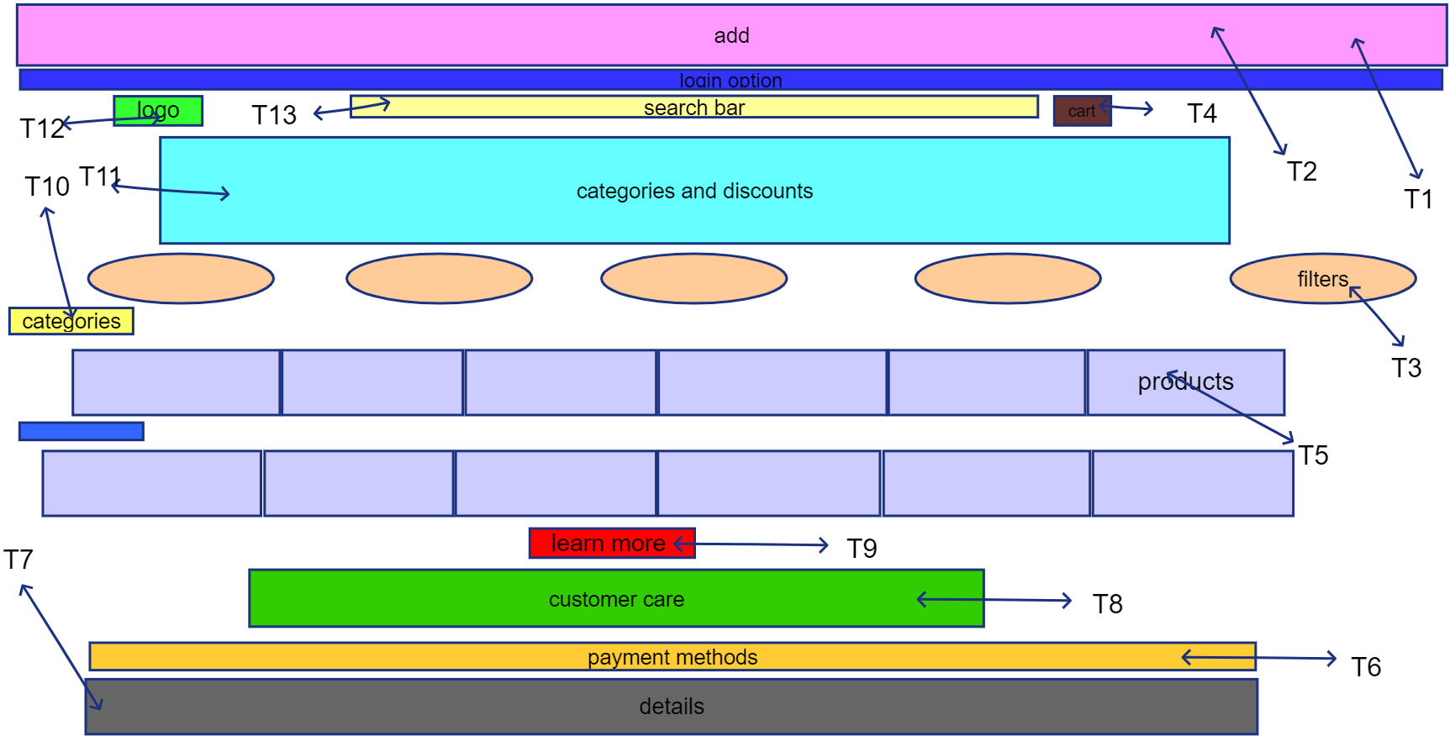

Tag | User Interactions | Admin Interactions
T1 | As a user, I shall be able to see various options or actions like "add/login" on the right side of the page. | As an admin, I shall be able to manage the options displayed on the right side of the page.
T2 & T3 | As a user, I shall be able to click on "filters" to reveal options and apply them to narrow down product searches. | As an admin, I shall be able to define, update, and monitor the available product "filters."
T4 | As a user, I shall be able to click on the "cart" icon to view my selected items. | As an admin, I shall be able to manage the contents and functionality of the shopping "cart."
T5 | As a user, I shall be able to see a section displaying various products. | As an admin, I shall be able to add, remove, and manage the products displayed in this section.
T6 | As a user, I shall be able to see the available payment methods. | As an admin, I shall be able to manage and update the available "payment methods."
T7 | As a user, I shall be able to view detailed information about the website or company. | As an admin, I shall be able to edit and update the "details" section of the website.
T8 | As a user, I shall be able to access customer care services. | As an admin, I shall be able to oversee and manage the "customer care" section.
T9 | As a user, I shall be able to click on "learn more" to get additional information. | As an admin, I shall be able to update the content accessible through the "learn more" button.
T10 & T11 | As a user, I shall be able to click on "categories" to explore different product groups and see discounts. | As an admin, I shall be able to manage, add new "categories," and update discounts.
T12 | As a user, I shall be able to click on the "logo" to return to the home page. | As an admin, I shall be able to update the "logo" of the website.
T13 | As a user, I shall be able to use the "search bar" to find specific products or information. | As an admin, I shall be able to monitor search queries made through the "search bar."

Image 2:

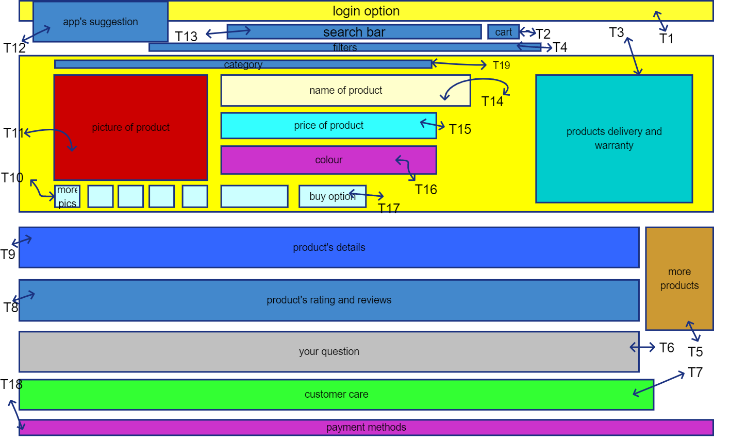

Tag | User Interactions | Admin Interactions
T1 | As a user, I shall be able to see various options or actions like "add/login" on the right side of the page. | As an admin, I shall be able to manage the options displayed on the right side of the page.
T2 | As a user, I shall be able to click on the "cart" icon to view my selected items. | As an admin, I shall be able to manage the contents and functionality of the shopping "cart."
T3&T5 | As a user, I shall be able to see a section displaying various products. | As an admin, I shall be able to add, remove, and manage the products displayed in this section.
T4 | As a user, I shall be able to click on "filters" to reveal options and apply them to narrow down product searches. | As an admin, I shall be able to define, update, and monitor the available product "filters."
T6 | As a user, I shall be able to ask a question from seller. | As an admin, I shall be able to monitor wither the seller is answering the question or not.
T7 | As a user, I shall be able to access customer care services. | As an admin, I shall be able to oversee and manage the "customer care" section.
T8 | As a user, I shall be able to click on "Product rating" to get rating and reviews. | As an admin, I shall be able to point out the product with maximum and least rating.
T9 | As a user, I shall be able to view detailed information about the website or company. | As an admin, I shall be able to edit and update the "details" section of the website.
T10 | As a user, I shall be able see more images uploaded by the seller. | As an admin, I shall be able to modify the minimum and maximum number of images and their size.
T11 | As a user, I shall be able to see the selected image here. | As an admin, I shall be able to update image size.
T12 | As a user, I shall be able to explore suggested apps. | As an admin, I shall be able to monitor and modify suggested apps.
T13 | As a user, I shall be able to use the "search bar" to find specific products or information. | As an admin, I shall be able to monitor search queries made through the "search bar."
T14 | As a user, I shall be able to see product name and get product link after clicking on it. | As an admin, I shall be able to see the profile of the seller.
T15 | As a user, I shall be able to see product price and get other charges including delivery. | As an admin, I shall be able to calculate company’s profit and taxes.
T16 | As a user, I shall be able to see available colors of this product. | As an admin, I shall be able to update the color if available or not.
T17 | As a user, I shall be able to buy the product. | As an admin, I shall be able to see the bank details of the seller.
T18 | As a user, I shall be able to see the available payment methods. | As an admin, I shall be able to manage and update the available "payment methods."

Image 3:

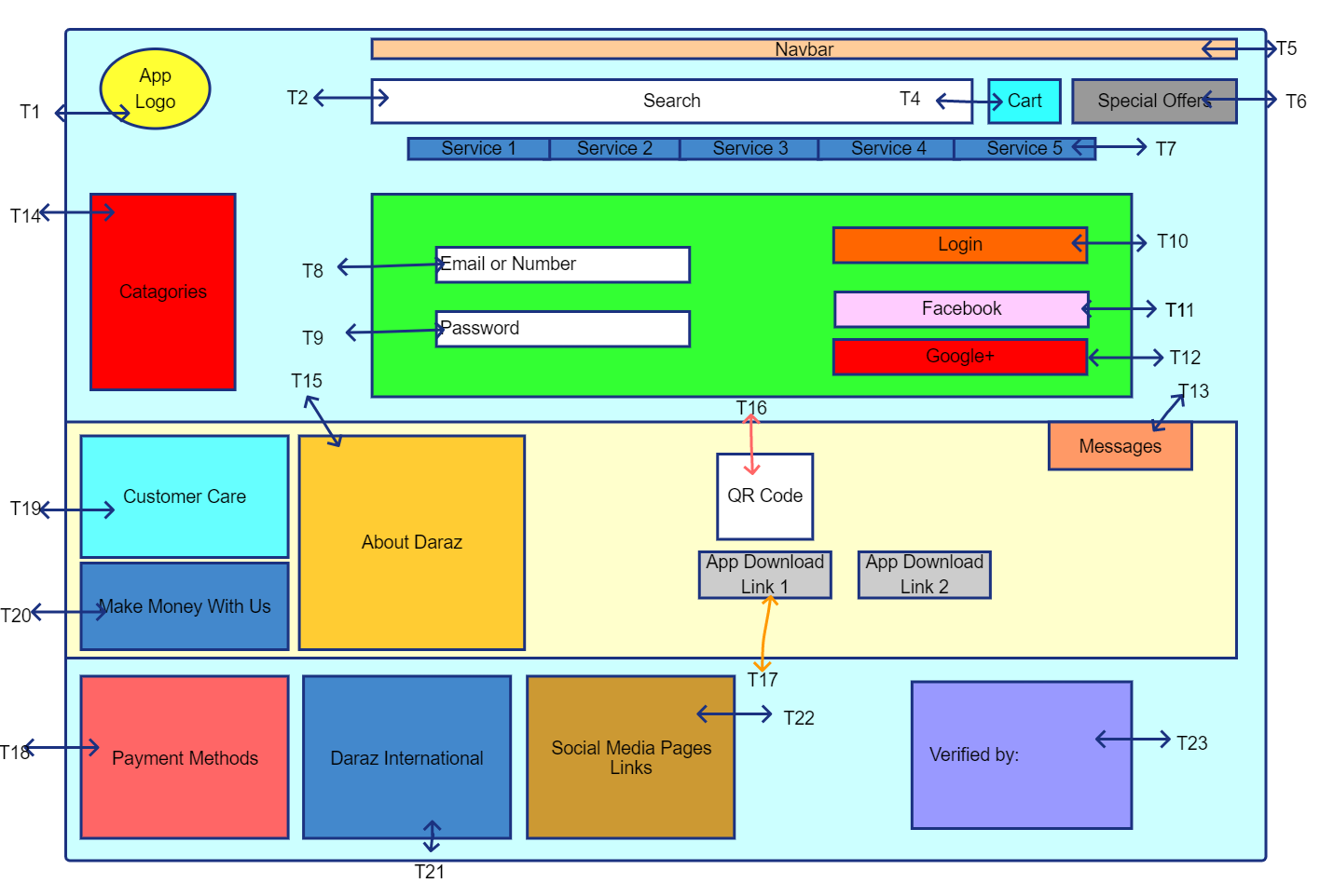
Tags | User | Admin
T1 | As a user, I shall be able to click on the "logo" to return to the home page. | As an admin, I shall be able to update the "logo" of the website.
T2 | As a user, I shall be able to use the "search bar" to find specific products or information. | As an admin, I shall be able to monitor search queries made through the "search bar."
T5 | As a user, I shall be able to see a section displaying various products. | As an admin, I shall be able to add, remove, and manage the products displayed in this section.
T6 | As a user, I shall be able to see various discounts and offers. | As an admin, I shall be able manage the products displayed in this section.
T7 | As a user, I shall be able to access different services by platform. | As an admin, I shall be able to oversee and manage the "Services" section.
T8 | As a user I shall be able to enter my phone number or email to create an account or log in. | As an admin I shall ensure the phone number or email input field correctly captures user data for account creation/login.
T9 | As a user I shall be able to enter my password to log into my account. | As an admin I shall ensure the password input field securely processes user credentials.
T10 | As a user I shall be able to click the 'Login' button to access my account. | As an admin I shall ensure the 'Login' button successfully authenticates users.
T11 & T12 | As a user I shall be able to use Facebook or Google to sign up or log in. | As an admin I shall ensure social login integrations (Facebook, Google) are functional and secure.
T13 | As a user, I shall be able to access different notifications by platform. | As an admin, I shall be able to oversee and manage the notifications.
T14 | As a user, I shall be able to click on "categories" to explore different product groups. | As an admin, I shall be able to manage, add new "categories".
T15 | As a user, I shall be able to access different contact information by platform. | As an admin, I shall be able to update the contact information
T16 | As a user, I shall be able to access download link via QR code provided by platform. | As an admin, I shall be able to update the link to download app.
T17 | As a user, I shall be able to access download link provided by platform. | As an admin, I shall be able to update the link to download app.
T18 | As a user, I shall be able to see the available payment methods. | As an admin, I shall be able to manage and update the available "payment methods."
T19 | As a user, I shall be able to access customer care services. | As an admin, I shall be able to oversee and manage the "customer care" section.
T20 | As a user, I shall be able to access information or contact us. | As an admin, I shall be able to update information or set employ to contact.
T21 | As a user, I shall be able to access website of selected country. | As an admin, I shall be able to manage the section and update links.
T22 | As a user, I shall be able to access product pages on different social media platforms. | As an admin, I shall be able to check links for these platforms.
T23 | As a user, I shall be able to verify it is verified or not. | As an admin, I shall be able to see the contract with these organization.

Image 4:

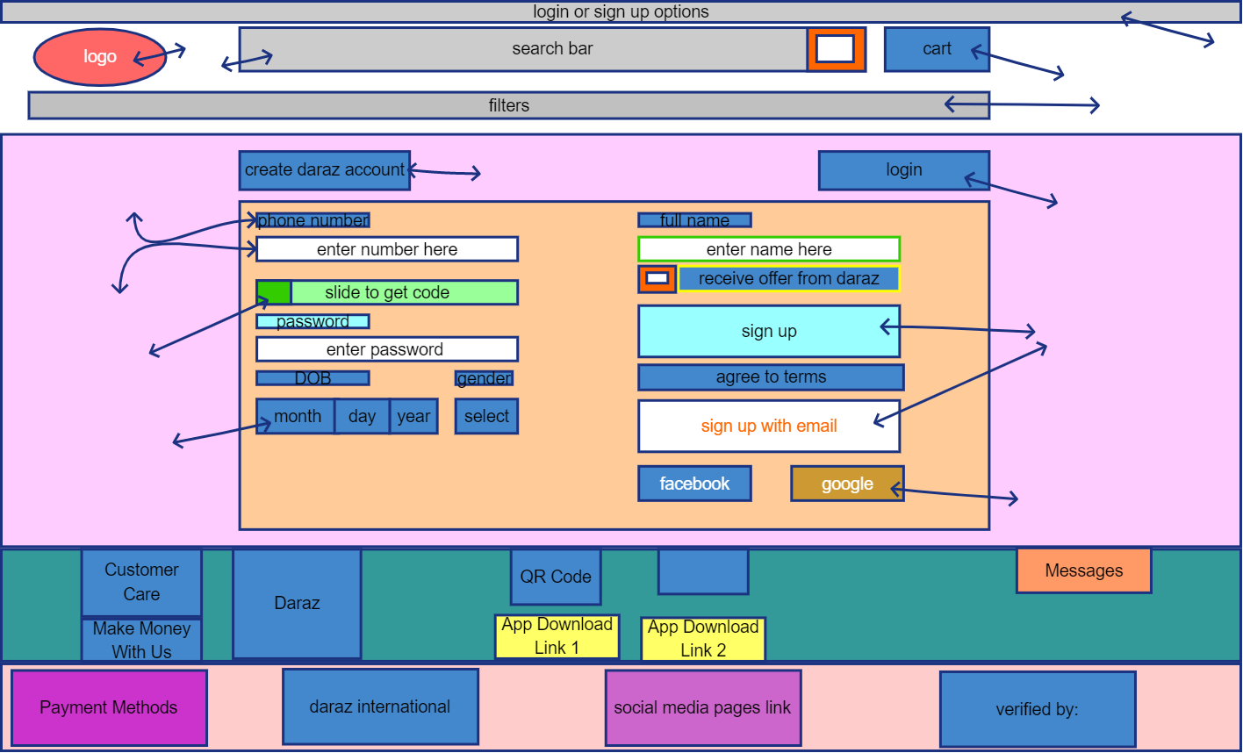

Tag | User Story (User) | User Story (Admin)
T1 (Logo) | As a user I shall be able to click on the logo to navigate to the home page. | As an admin I shall ensure the logo links correctly to the home page.
T2 (Search Bar) | As a user I shall be able to type keywords into the search bar to find products. | As an admin I shall monitor search queries and results to improve product discoverability.
T3 (Phone Number Input) | As a user I shall be able to enter my phone number to create an account or log in. | As an admin I shall ensure the phone number input field correctly captures user data for account creation/login.
T4 (Slide to Get Code) | As a user I shall be able to slide to get a verification code sent to my phone number. | As an admin I shall ensure the 'slide to get code' functionality securely sends verification codes.
T5 (Password Input) | As a user I shall be able to enter my password to log into my account. | As an admin I shall ensure the password input field securely processes user credentials.
T6 (DOB  Selection) | As a user I shall be able to select my date of birth (month, day, year) during account creation. | As an admin I shall ensure the date of birth selection fields accurately capture user demographic data.
T7 (Customer Care Link) | As a user I shall be able to click on 'Customer Care' to access support options. | As an admin I shall ensure the 'Customer Care' link directs users to the appropriate support resources.
T8  (Login/Signup Options) | As a user I shall be able to see options to log in or sign up. | As an admin I shall ensure the login/signup options are clearly visible and functional.
T9 (Cart Icon) | As a user I shall be able to click on the cart icon to view items in my shopping cart. | As an admin I shall ensure the cart icon accurately reflects the number of items and links to the shopping cart page.
T10 (Filters) | As a user I shall be able to apply filters to refine my product search results. | As an admin I shall ensure the filters are working correctly and provide relevant options for product categorization.
T11 (Login Button) | As a user I shall be able to click the 'Login' button to access my account. | As an admin I shall ensure the 'Login' button successfully authenticates users.
T12 (Sign Up Button) | As a user I shall be able to click the 'Sign Up' button to create a new account. | As an admin I shall ensure the 'Sign Up' button initiates the account creation process.
T13 (Sign Up with Email) | As a user I shall be able to click 'Sign up with email' to create an account using my email address. | As an admin I shall ensure the 'Sign up with email' option correctly processes email-based registrations.
T14 (Social Login Buttons) | As a user I shall be able to use Facebook or Google to sign up or log in. | As an admin I shall ensure social login integrations (Facebook, Google) are functional and secure.
T15 (Messages) | As a user I shall be able to view system messages or notifications. | As an admin I shall ensure system messages are delivered effectively to users.

